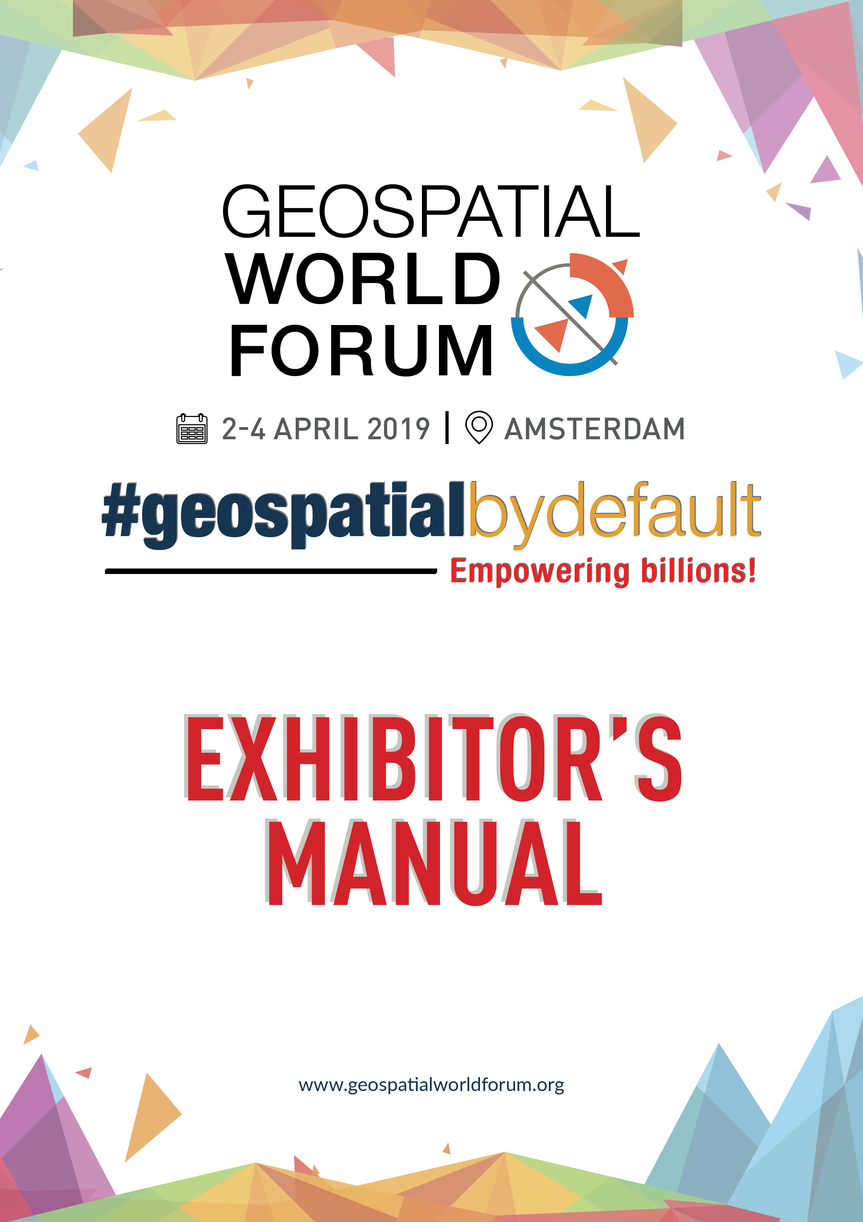

Dear Colleague,
It is my great pleasure to announce that Geospatial World Forum 2019 is back in The Netherlands again after 2 years of journey in India for connecting communities, developing geospatial business and serving better policy environment within the domain. Our presence of two dynamic decades have witnessed significant evolution in the technology and its applications. It has been our privilege to be a part of this momentum and contribute our bit to this technology revolution. We have strived to bring geospatial as a tool in the hands of people who matter, to unleash its power for national development and enhanced quality of life.
Just like a picture is worth a thousand words, there is no better way to gain insight into technology capabilities than hands-on exposure and having experts behind the scene explain first hand exactly what their technology can do for you. With this philosophy, exhibitions at our conferences have always been as integral to our activities as the thought-provoking presentations and discussions. Through these years, leading geospatial technology players have chosen this platform to forge closer ties with their stakeholders, while the geospatial technology beneficiaries have found this platform to be the go-to source for getting updates on the latest in the field. Going by the sustained belief of our partners in our platform, we are truly humbled to have been a part of your journey and collectively growing the geospatial industry which is now one of the fastest growing industries globally to reckon with. We take it as our serious responsibility to continue this sustained association and will always strive to raise the bar to meet your expectations.
Once again, we thank you for choosing Geospatial World Forum 2019 as your business partner to showcase your offerings to the global geospatial community. In the next few pages, you will find comprehensive information on all you need to know about exhibiting at Geospatial World Forum 2019 taking you through the processes and deadlines in an easy-to-use format. Should there be any further queries or clarifications, please do not hesitate to get in touch with us. Our entire team is available to make your participation memorable.
We look forward to working with you during the next few months to ensure you have a successful show. Thank you once again and see you in Amsterdam.
Regards,
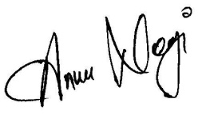
ANNU NEGI
Chief Operating Officer

TABLE OF CONTENTS
- General Information | Section 1
  - Organiser………………………..……………………………………………………………4
  - Conference and Exhibition Venue..………….…………………………………………….4
  - Accessibility to the Venue ………………………………………………………………….5
  - Car Park Taets ...…………………………………………………………………………….5
  - Public Transport ……………………………………………………………………………..5
  - Exhibition Dates & Opening Hours ………………………………………………………..6
  - Opening Ceremony and Exhibition Visit …….……………………………………………6
  - Smoking ………………………………………………………………………………………6
  - Currency ……………………………………………………………………………………...6
  - Tourist Information …………………………………………………………………………..6
  - Visa …………………………………………………………………………………………...6
- Technical Information | Section 2
  - Build-up Schedule …………………………………………………………………………..7
  - Possession of Exhibit Space ……………………………………………………………….7
    - Plan Approval ………………………………………………………………8
    - Carpentry …………………………………………………………………...8
    - Completion ………………………………………………………………….8
    - Exhibitor Facilities ………………………………………………………….8
  - Booth Inspection …………………………………………………………………………….9
  - Technical Specification ……………………………………………………………………..9
    - Building Height ……………………………………………………………..9
    - Electricity ………………………………………………………………….10
    - Plug, Sockets and Adapters …………………………………………….10
    - Suspension and Rigging ………………………………………………...11
  - Internet ……………………………………………………………………………..11
  - Delivery and Removal of Exhibits …………………………………………….....11
    - Waste ……………………………………………………………………...12
      - Storage and Waste Material ……………………………………12
    - Dismantle of Exhibits …………………………………………………….13
  - Stand Number and Final Allocation ……………………………………………..13
  - Personal Belongings ……………………………………………………………...13
- Rules, Instructions and Regulations | Section 3
  - Rules, Instructions and Regulations …………………………………………….14
  - Force Majeure ……………………………………………………………………..15
  - Insurance of Contractors …………………………………………………………15
- Exhibitor Registration | Section 4
  - Registration Guidelines …………………………………………………………..16
  - Registration of Contractor ………………………………………………………..16
- Vendor Contact Details for Services …………………………………………………….16

Organiser
Regional Office
Address
Geospatial Media and Communications BV
Donauweg 10, 1043 AJ,
Amsterdam, The Netherlands
+31 6 8134 6105
Head Office
Geospatial Media and Communications Pvt. Ltd.
A-145, Sector 63, Noida, Uttar Pradesh, India. Pin: 201601
+91 120 461 2500(P), +91 120 461 2555(F)
Contact Person
Tarun Kumar (Mr.) (Exhibition Logistics)
tarun@geospatialmedia.net
+91 99 58 727 957
Conference and Exhibition Venue
TAETS ART AND EVENT PARK
Address | Contact Details
Hemkade 16 (Hembrugterrein)  1506 PR Amsterdam – Zaandam,  The Netherlands. | Telephone +31 (0)20 – 788 2600  Fax +31 (0)20 – 655 4361  E-mail: info@taets.com
Exhibition Area
Black Box

Accessibility to the Venue
- Taets Art and Event Park is a venue situated in three extremely wonderful national monuments, Building 41 | Gallery & Theatre, Building 43 | Event Area & Meeting area and Hall 1 | Black Box.
- These beautiful buildings are located next to the North Sea Canal near Amsterdam. Although the terrain’s character and its direct surroundings refer to days long gone, the location is fitted with all modern conveniences.
- A high-speed train connects Zaandam and Schiphol (Amsterdam) Airport. It takes only 22 minutes to get from the airport to Zaandam.
- A large number of open air parking facility is available in the venue free of cost.
- Transportation within the city by bus connecting to various train, tram, subway, (green) taxi, water taxi or bike taxi.
- Shuttle will be available from Zaandam station to venue
Public Transport
You may use Google maps or following link to get the information of public transport to reach to the convention center:
https://moovitapp.com/index/en/public_transit-Taets_Art_Event_Park-Netherlands-site_40683143-101
Car
From Amsterdam
Ring A10, direction Zaanstad
Exit Oostzaan, Zaandam-Zuid, Het Twiske
Turn right onto N516 / Kolkweg, direction Kolkweg-Noord, Zaandam-Zuid
After 3 kilometers (after the Den Uyl bridge) turn left to the N203 / Provincial road
Turn left after 250 meters (at the roundabout)
Follow the road and signs to Taets Art and Event Park
Shuttle Services
Shuttles will be available on a regular interval from Zaandam Station to Taets Art and Event Park and back. The schedule will be available online near to the conference.

Exhibition Dates & Opening Hours
Tuesday 02 April 2019 1300 hrs 1930 hrs
Wednesday 03 April 2019 0900 hrs 1800 hrs
Thursday 04 April 2019 0900 hrs 1600 hrs
- Stands must be staffed at all times during opening hours of the exhibition.
- If a booth is not staffed when the exhibition opens, the organisers will remove protective covers and will turn on the stand lights.
- For Buildup and Breakdown Schedule see page number 7.
Opening Ceremony and Exhibition Visit
Exhibitors are invited to the Opening Ceremony on Tuesday 02 April 2019 from 1300 – 1930 hrs at Taets Art and Event Park
Smoking
By law, smoking is prohibited in all public buildings in the Netherlands. Naturally, the Taets Art and Event Park fully complies with this legal requirement and smoking is therefore not permitted in its building.
Currency
The currency in The Netherlands is EURO (EUR). For up-to-date exchange rates, please refer to a currency exchange site on the Internet, e.g. www.xe.com/ucc.
Tourist Information
For tourist information on The Netherlands, please refer to the following website: https://www.iamsterdam.com/en/plan-your-trip
Visa
Don’t forget to check with your travel agency, or with the Dutch consulate or embassy in your country, if you need a visa to enter the country.

Technical Information ………………………………………………..…………. Section 2
Build-up Schedule
Schedule for exhibitors using the standard stand construction package (Shell Scheme)
Monday 01 April 2019 1600--2200 hrs Bringing in and installation of exhibits
Monday 01 April 2019 2200--2200 hrs Aisles must be clear and empties & packing materials taken for storage. Installation of exhibits inside the stands only, no more movements in the aisles in view of cleaning of aisles.
Schedule for exhibitors using the Startup Zone package (Octonorm counters)
Monday 01 April 2019 1600--2200 hrs Bringing in and installation of exhibits
Monday 01 April 2019 2200--2200 hrs Aisles must be clear and empties & packing materials taken for storage. Installation of exhibits inside the stands only, no more movements in the aisles in view of cleaning of aisles.
Schedule for exhibitors bringing and building their own stand (Raw Booth)
Sunday 31 March 2019 1000—2200 hrs Move in and All construction
Starts
Monday 01 April 2019 0900--2100 hrs All construction works must be finished. Aisles must be clear and empties & packing materials taken for storage
Monday 01 April 2019 2200--2200 hrs Installation of exhibits inside the stands only, no more movements in the aisles in view of cleaning of aisles.
- IMPORTANT
As an exhibitor, we require the following from you latest by 1 March 2018 for the inclusion of the same in our Exhibitor’s Profile:

- 100 words company profile in MS Word Format
- High resolution company logo in JPEG
- Contact person name and email id
- Fascia name in MS Word Format

Possession of Exhibit Space
Exhibitors using any contractor other than the official stand construction contractor for their stalls will get possession, only if drawings / designs for their stands have been approved by the organizer and the security deposit is in place.

Possession of raw space will be given to those exhibitors who have made FULL PAYMENT, and have provided performance bonds/ security deposit receipt of Euro 2000 in the name of Geospatial Media and Communications BV to Tarun Kumar by 1 April 2019. The deposit will be returned to the exhibitor just after the exhibition gets over and no damage in the property is made. This deposit will be given by the contractor of raw booth, if the contractor is other then official contractor.

Contractual working hours agreed with the Taets Art and Event Park do not allow for any delay in leaving the exhibition area after contractual hours. If an exhibitor, his staff, his contractor or his supplier does not leave the premises at, or before, the times specified, the exhibitor will be held responsible for additional rental fees incurred.
Plan approval

Exhibitors who have reserved ‘raw space’ and using a contractor other than the official stand construction contractor, must submit the layout design of their stands, for approval to the organizer. This is to prevent costly alterations on site being required by the hall owner and the organizer. Deadline for submission is 1 March 2019.

These plans shall include elevation drawings. One set of drawings duly approved or with suggested modifications, if necessary, will be returned to the exhibitor. Actual construction and display in the stand must strictly conform to the drawings approved by the organizer.

Carpentry
Contractors and exhibitors are requested to strictly observe that carpentry inside the halls during build-up is not permitted. Only assembly of the display and minor finishing/touching up is allowed. Contractors violating this guideline will be prevented from continuing work on the exhibitors stand inside the hall. It’s mandatory to use an old flex sheet or plastic sheet on the ground before starting the installation of your raw booth.
Completion
Installation of stands /booths should be completed by 2200 hrs on 1 April 2019. The cleaning services for the booth must be booked with A-Booth (Official Contractor).
Exhibitor facilities
Each shell scheme booth comes with following Items:
- White walls in an aluminium frame of 2,50 x 1,00 meter
- Closed fascia with a name panel of 200 cm meters width
- Wall socket of 500 watt, inclusive of a main connection of electricity
- Each open side a number and company name, colour black
- 1 spot per 4 sqm
- Esolita carpettiles

Each Start up Zone booth comes with following Items:
- 1 Meter Wide Information Counter
- Closed fascia with a name panel of 100 cm meters width
- Electrical socket of 500 watt, inclusive of a main connection of electricity
- 2 Stools/Chair

Photo impression shell scheme.
Please Note:
- No rebate will be given if the exhibitor decides not to avail any of the above shell scheme provisions
- Exhibitors must order furniture and additional power supply, which will be on paid basis. Please find below mentioned link for the same:
https://geospatialworldforum.org/manual.html

Booth Inspection
Inspection of the booths will be carried out continuously during build-up procedures to make sure that exhibitors have received the services ordered, and to see if the instructions of and on behalf of the organizer and Taets Art and Event Park have been taken into account.
Technical Specification
Below are important technical specifications related to the use of your exhibit space, the standard stand construction package, and the exhibition area in general.

Building Height
- The building height is 2.50 m for all shell scheme stand walls and objects inside the stand (height measured from the floor of the hall, not from a technical/raised floor).
- For higher raw booth more than 3 m, permission is required from organiser by submitting the layout latest by 1 March 2019.
Electricity
Voltage: 230V/400V, 50 Hz (50 cycles). The connections come from ducts in the floor.
For all the exhibitors, power connection from the main distribution box (DB) inside the exhibitors’ area will be provided by the official contractor commencing 02 April 2019. All the exhibitors are requested to order through electricity order form for their electricity requirement of booth. Please order the electricity of booth through our official contractor A Booth.
Connection to the exhibitor’s equipment from the distribution box (DB) inside the exhibitor’s area will be operated by the exhibitors. A work completion-cum-listing report must be provided to the official electrical contractor after the exhibitor has completed his work by 1 April 2019 by 2200 hrs.
Each stand will be provided with electric power at one or more main points depending on the requirement on additional charges. Please log on to the website to order the additional electricity for your booth. Exhibitors should use distribution boards, individual isolation switches for exhibits, and insulated cables or metal conduits for connecting power supply to the exhibits.
Exhibitors who use power for general lighting and running of equipment/exhibits in excess of their specified load will attract penalties and/or disconnection.
Exhibitors must install separate and independent switch connections for each exhibit. Alternate connections or throw-over switches are not allowed. Power load is not allowed to be taken from the sockets.
All the main electrical supply points must be kept easily accessible for operation and repairs in the event of emergency. Main electrical supply points should not be concealed or covered.
Exhibitors are advised to install equipments voltage stabilizers/UPS for their sophisticated equipments.
Exhibitors are advised to exercise the highest level of safety precautions and engage the services of only qualified professionals for electrical wiring and installations.

Plug, Sockets and Adapters
Regular European plugs and sockets (Schuko) are used in The Netherlands.
Suspension and Rigging
The height of the hall allows suspensions and rigging. Please let us know if you need suspension for your booth. This need careful planning (build-up time is limited!) and the approval of Taets Art and Event Park.
No suspensions are to be made from the ceiling of the exhibition area directly through any outside contractor, nor may any fixing be made to the floor, walls or any other part of the building. Please contact our official contractor for rigging services well in advance.
Delivery and Removal of Exhibits
For loading and unloading of goods intended for Taets Art and Event Park, please use the loading area of the Black Box. Following instruction must be followed for deliveries:
- Exhibits will NOT be allowed to take out of the exhibition halls during the exhibition period.

- Removal or delivery of exhibition stores in or out of the exhibition hall is not permitted during the open hours of the exhibition.

- Such removal, delivery or replenishment of stock may only be carried out before opening hours in the morning or after closing time in the evening. If you wish to remove any item, a “GOODS REMOVAL PASS” must be obtained from the venue duly signed and stamped by the organizer.

- Goods removal pass: At the close of the exhibition, in order to remove your goods smoothly, safely and easily, the following paperwork must be carried out. Make 4 copies of an itemized list showing equipment and material required to be exited from Taets Art and Event Park. These copies must be on the exhibitor company’s letterhead, duly stamped with the company’s official seal and signed by an authorized person. Get all copies attested and stamped by Geospatial World Forum 2019 organizer.
- Geospatial Media has appointed ‘DB Schenker’ as the official logistic Contractor for Geospatial World Forum 2019.
WASTE
Exhibitors are advised not to throw waste material from their stands on the aisles. Empty cases /crates should not be left in the aisles to ensure the safety of all show participants.

Storage and Waste Materials
The organizer is unable to provide storage facilities in the hall for packing cases, surplus materials or other property of the exhibitors. Arrangements for safekeeping of such items must be made with the freight forwarder.
During move-in, construction of stands and removal of exhibits, the passageways in the exhibition halls must not be obstructed with packing materials, construction materials or debris. Contractors are responsible for removing their own cuts-offs and waste on each day of build-up and breakdown. Use of passageways behind stalls for storage of empty, waste or surplus material is strictly prohibited.
Exhibitors are requested to book cleaning services with official contractor. The organizer reserves the right to invoice exhibitors for excessive packing materials and discarded crates or cartons.
Dismantle Of Exhibits
The halls have to be handed over to the Taets Art and Event Park promptly on the final day of break-down. Exhibitors must ensure that their exhibits and stand materials are removed by 2200 hrs on 4 April 2019. The organizer will dispose off any items remaining in the hall beyond this time, and the management will not accept responsibility for any loss or damage. Costs involved will be borne by the defaulting exhibitor.

As it is impossible to provide complete protection against theft, exhibitors should ensure that their exhibits are properly insured. We do remind you that you are responsible for your exhibits at all times and that they will be at greatest risk during buildup and breakdown. Do not take chances with your valuables- once they are lost, it will be very difficult or impossible to recover them. The organizer will accept no responsibility for losses or damages of any kind. Keep your passport, exhibit goods and laptop etc. under your strict supervision at all times.

Stand Number and Final Allocation
Stand locations and stand numbers will be (re-)confirmed by Geospatial Media and Communications in case it is necessary to change an exhibitor’s stand number or stand location, the exhibitor will be notified immediately.
Animals
It is not allowed to bring any animals into the building.
Personal Belongings
All exhibitors / participants must take care of their personal belongings at all times. The organizer will not be held responsible for any damage / loss etc.

Rules, Instructions and Regulations…………………………..…………. Section 3
Rules, Instructions and Regulations
- Raw space exhibitors / contractor will also be responsible for the proper behavior of the contractor, if the contractor appointed is other than the ‘Official Contractor’.
- The exhibitors/ contractor will also have to bear any charges levied by the venue Taets Art and Event Park for damages caused to property, walls, flooring, etc.
- Exhibitors’ contractors are requested to avoid designs blocking or boxing-in other exhibitors’ stands. The back wall shall never be left unsightly
- Exhibitors / contractors are not permitted to fabricate or build from scratch, stands inside the halls. They should prefabricate and fit sub-sections of the stand inside the hall. Only finishing and touching up of paint (not complete painting) is permitted inside the hall.
- Exhibitors/contractors must ensure that finishing/ painting of the stand does not result in spillage.
- Exhibitors / contractors must remove cut-offs and debris from inside their stand, and ensure that the stand is completed by 2200 hrs 1 April 2019.
- Exhibitors’ contractors are not allowed to block the aisles inside the hall. Packing cases and crates belonging to contractors and exhibitors and material lying on the aisle will be removed under the instruction of the organizer at the exhibitor’s cost.
- No part of any structures may extend beyond the boundaries of the stand allocated to the exhibitor by the organizer.
- A finished back wall, except in the case of an island or peninsula stand, must be provided.
- Where ‘raw space only’ stands rest on a shell scheme package stand, the walls of the shell scheme package may not be utilized by the ‘raw space’ exhibitor.
- Nailing or puncturing the shell scheme panels is strictly prohibited. Any such damage will be made good at the expense of the exhibitor.
- In case of heavy machinery, the maximum height of 2.5 mts. can be accommodated in the hall.
- Raw space exhibitors are requested to take approval from the organiser for exceeding the height of their booth more than 3 meters.
- We would highly recommend that you practice cautious with regard to the move in / build up and tear down / move out phase of your exhibitions. We would recommend the following additional precaution actions to be taken and enforced to contractors and exhibitors to minimize the damage to the Centre.
  - Protection of the carpet by old carpet or plywood for the movement of heavy duty trolley during move in and move out.
  - Protection of the carpet particular on the aisle with plastic sheet, plywood or used carpet during build up
  - No sanding, sawing, metal cutting, major painting and major construction allowed.
Force majeure
If due to force majeure or other unavoidable circumstances, the organisers are forced to cancel the exhibition, the exhibitor will not be entitled to claim damages or compensation of any kind. The organisers reserve the right to reschedule the event in the interest of the exhibition.
Insurance for contractors & service men
Exhibitors are liable to cover their own staff and the contractors they hire for booth set up and dismantle for any physical damage on site. In case of any mishap, the organisers will not be liable to bear any such damages.

Exhibitor Registration.......................................…………………..…………. Section 4
Exhibitor Registration
Registration Guidelines:
- Exhibitors are requested to register the names of representatives from their organization not later than 15 March 2019.
- Please note that it is compulsory for each exhibitor to wear their exhibitor registration badge for the duration of the Trade Show
- Identification badges can be collected from Geospatial World Forum 2019 conference registration desk at the conference venue on any of the registration days starting from 1 April 2019 onwards
Registration of Contractor
The Contractor, who are building up and breaking down exhibition booths, need to wear their badges. This is to ensure that only entitled person is entering the building. It is mandatory to send complete contact details of the contractor and their team to organiser for registration. At the first day of build-up we will provide the badges at registration area.
.

Vendor Contact Details for Services

Service | Official Vendor | Order Due Date
Furniture & Plant Order Form  Electricity Order Form  Technical Order Form  Internet Order Form  Booth Cleaning Order Form | Daan Streur  A-Booth Exhibition Services  T: +31 (0)75 - 6225581  F: +31 (0)75 -6225582  E: Daan@A-booth.nl | 01 March 2019
Shipping Manual | DB Schenker Logistics Nederland  Europaplein 2 -22 / P9  NL - 1078 GZ Amsterdam  The Netherlands  T: +31 (0)20 549 2790  E: nl.sm.ams.fairs-amsterdam@dbschenker.com | Please Refer to the Shipping Manual
Company Information Form  Fascia Name Form  Security Deposit Form | Yash Agarwal  Geospatial Media and Communications  M: +91 86 04 025 508  Fax: +91 120 461 2555  E: yash@geospatialmedia.net | 01 March 2019

